|  |  |  |  |
| --- | --- | --- | --- |
|  | Bansilal Ramnath Agarwal Charitable Trust's  Vishwakarma Institute of Information Technology  **Department of**  **Artificial Intelligence and Data Science** | | |
| Name: Kalpak Nemade | | | |
| Class: TY | Division: A | | Roll No: 371070 |
| Semester: V | | Academic Year:2022-2023 | |
| Subject Name & Code: Cloud Computing and Analytics | | | |
| Title of Assignment: Study and implementation of Infrastructure as a Service. | | | |
| Date of Performance: 28/08/2022 | | Date of Submission: 01/12/2022 | |

Aim: Study and implementation of Infrastructure as a Service.

Problem Statement: Study and implementation of Infrastructure as a Service.

Background Information:

* Infrastructure as a Service (IaaS) is also known as **Hardware as a Service (HaaS)**. It is one of the layers of the cloud computing platform.
* It allows customers to outsource their IT infrastructures such as servers, networking, processing, storage, virtual machines, and other resources. Customers access these resources on the Internet using a pay-as-per use model.
* With the help of the IaaS cloud computing platform layer, clients can dynamically scale the configuration to meet changing requirements and are billed only for the services actually used.
* IaaS is offered in three models: public, private, and hybrid cloud.
  + The **private cloud** implies that the infrastructure resides at the customer-

premise.

* + The **public cloud**, it is located at the cloud computing platform vendor's data

center.

* + The **hybrid cloud** is a combination of the two in which the customer selects the

best of both public cloud or private cloud.

* It also offers resources such as:
  + Virtual Machine disk storage
  + Virtual local area network
  + Load balances
  + IP addresses
  + Software bundles
* It is all about virtual servers, extended network, and remote storage. For this, no more large hardware investments, maintenance, or infrastructure are needed.

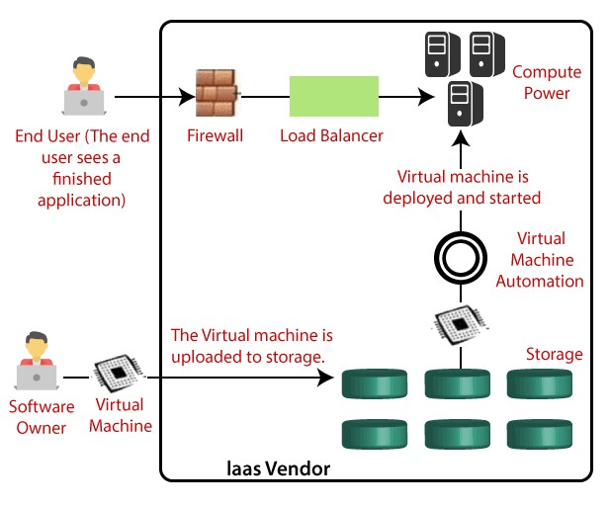

# Advantages of IaaS

1. We can dynamically select a CPU, memory, and storage configuration as per your requirements.
2. We can easily access the broad computing power available on the IaaS cloud computing platform.
3. We can easily remove the need for investment in rarely used IT hardware.
4. IT infrastructure is handled by the IaaS cloud computing platform vendors.

# Disadvantages of IaaS

1. IaaS cloud computing platform model totally depends on the internet.
2. IaaS is also dependent on the availability of virtualization services.
3. Require training to learn how to manage new infrastructure.
4. Having issues regarding data security due to multitenant architecture.

Cloud Resource Requirements: AWS Console Steps:

You can implement IaaS by selecting a suitable IaaS provider and training your team members to use the cloud computing services that the IaaS provider offers.

**Step 1] Identify your requirements:** It is important to understand your company’s

underlying infrastructure requirements for the use cases you want to start with. For

instance, web application hosting has different server and network resource requirements than big data analytics.

**Step 2] Select your team:** If your organization is new to digital transformation, it is better to start with a small core team that will lead the change going forward. The team can solve a small problem and talk about their results to create awareness and enthusiasm about cloud computing.

**Step 3] Select your IaaS provider:** Different cloud providers have different levels of capabilities. Do your due diligence so that you don't run into problems later. It is always best to go with a well-established IaaS provider who offers a range of services so that you can manage even changing requirements easily.

**Step 4] Migrate to the new infrastructure:** Migration is an incremental process that needs planning to avoid disruption. You can also choose to run hybrid clouds where some applications, or even components of the same application, run on your on-premises infrastructure and other components run on the IaaS provider’s infrastructure.

GitHub Repo Link:

https://github.com/mrkalpak/CCA-Assignemnt/

Conclusion:

IaaS cloud computing platform layer eliminates the need for every organization to maintain the IT infrastructure. AWS has significantly more services, and more features within those services, than any other cloud provider.